Creation of a Microservice “Users” – Microservice with MongoDB

What this User Service Does?
- Manages user information
- Uses MongoDB
- Uses MongoRepository
- Runs independently (separate microservice)

1. Maven Dependencies (pom.xml)
<dependencies>
<!-- Spring Boot Web -->
<dependency>
<groupId>org.springframework.boot</groupId>
<artifactId>spring-boot-starter-web</artifactId>
</dependency>

<!-- Spring Data MongoDB -->
<dependency>
<groupId>org.springframework.boot</groupId>
<artifactId>spring-boot-starter-data-mongodb</artifactId>
</dependency>
</dependencies>

2. Application Configuration (application.properties)
spring.data.mongodb.uri=mongodb://localhost:27017/E-CommDB
server.port=8080
✔ Separate database
✔ Separate port → independent service

3. Main Application Class
import org.springframework.boot.SpringApplication;
import org.springframework.boot.autoconfigure.SpringBootApplication;
@SpringBootApplication
public class DemoApplication {
public static void main(String[] args) {
SpringApplication.run(DemoApplication.class, args);
}
}

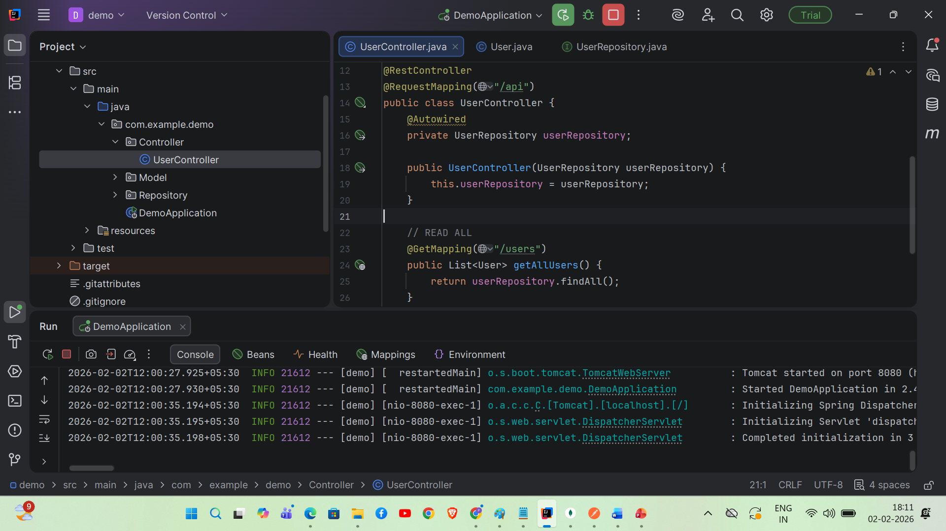

Folder Structure
Controller
----UserController.java
Model
----User.java
Repository
----UserRepository.java

4. UserController.java
package com.example.demo.Controller;
import com.example.demo.Model.User;
import com.example.demo.Repository.UserRepository;
import org.springframework.beans.factory.annotation.Autowired;
import org.springframework.web.bind.annotation.GetMapping;
import org.springframework.web.bind.annotation.RequestMapping;
import org.springframework.web.bind.annotation.RestController;
import java.util.List;
@RestController
@RequestMapping("/api")
public class UserController {
@Autowired
private UserRepository userRepository;
public UserController(UserRepository userRepository) {
this.userRepository = userRepository;
}
// READ ALL
@GetMapping("/users")
public List<User> getAllUsers() {
return userRepository.findAll();
}
}

5. User.java
package com.example.demo.Model;
import lombok.AllArgsConstructor;
import lombok.Data;
import lombok.NoArgsConstructor;
import org.springframework.data.annotation.Id;
import org.springframework.data.mongodb.core.mapping.Document;
@Data
@NoArgsConstructor
@AllArgsConstructor
@Document(collection="users")
public class User {
@Id
private String id;
private String name;
private String email;
}

6. UserRepository.java
package com.example.demo.Repository;
import com.example.demo.Model.User;
import org.springframework.data.mongodb.repository.MongoRepository;
import java.util.List;
public interface UserRepository extends MongoRepository<User, String> {
}

7. MongoDB Collection Example (users)
{
"_id": "65f1aa10e8a4b0012a002b1",
"name": "Ravi Kumar",
"email": "ravi@gmail.com"
}

8. Why This is a Microservice
- Runs independently on port 8080
- Has its own MongoDB database (users)
- Can be deployed as user-service.jar
- Communicates via REST APIs only
GET api/users

Add User Method UserController

@PostMapping
public User createUser(@RequestBody User user) {
return userRepository.save(user);
}
Since the @RequestMapping("/api")
We can hit this endpoint by the following:
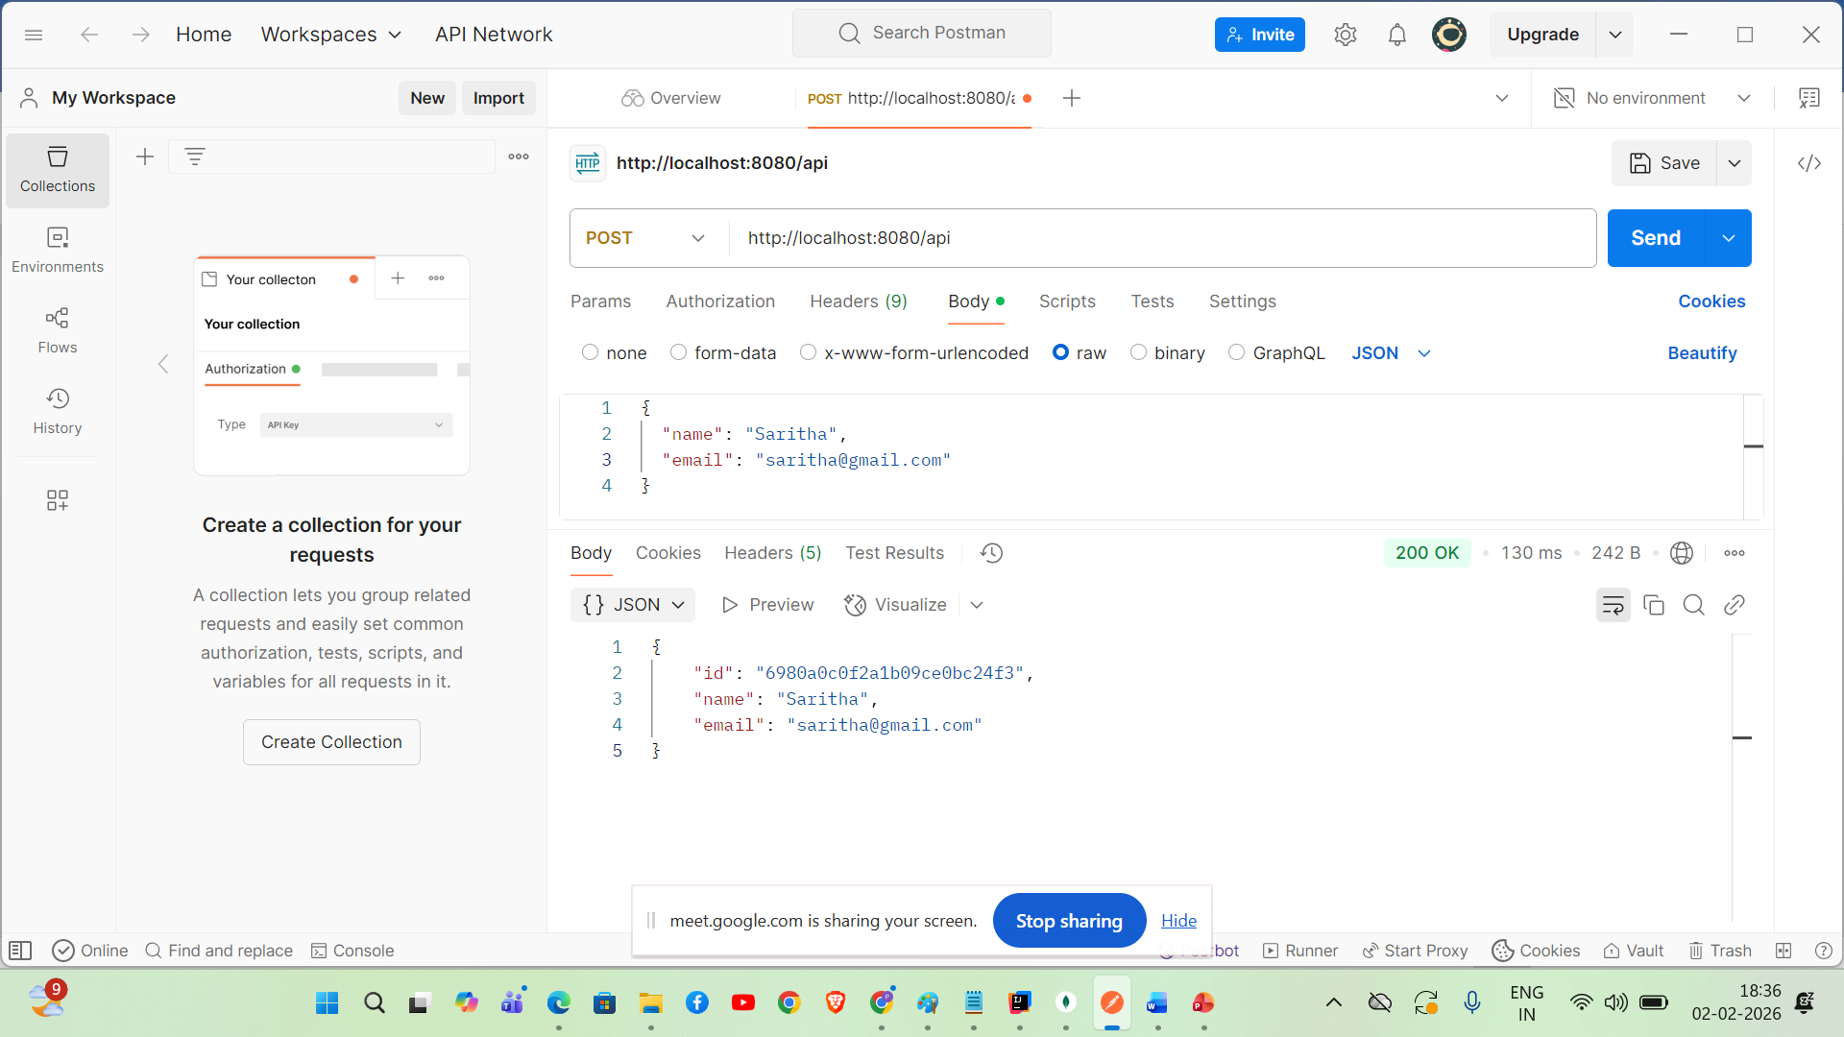

Retrieve specific document method in UserContoller

@GetMapping("/{id}")
public User getUserById(@PathVariable String id) {
return userRepository.findById(id).orElse(null);
}
Output
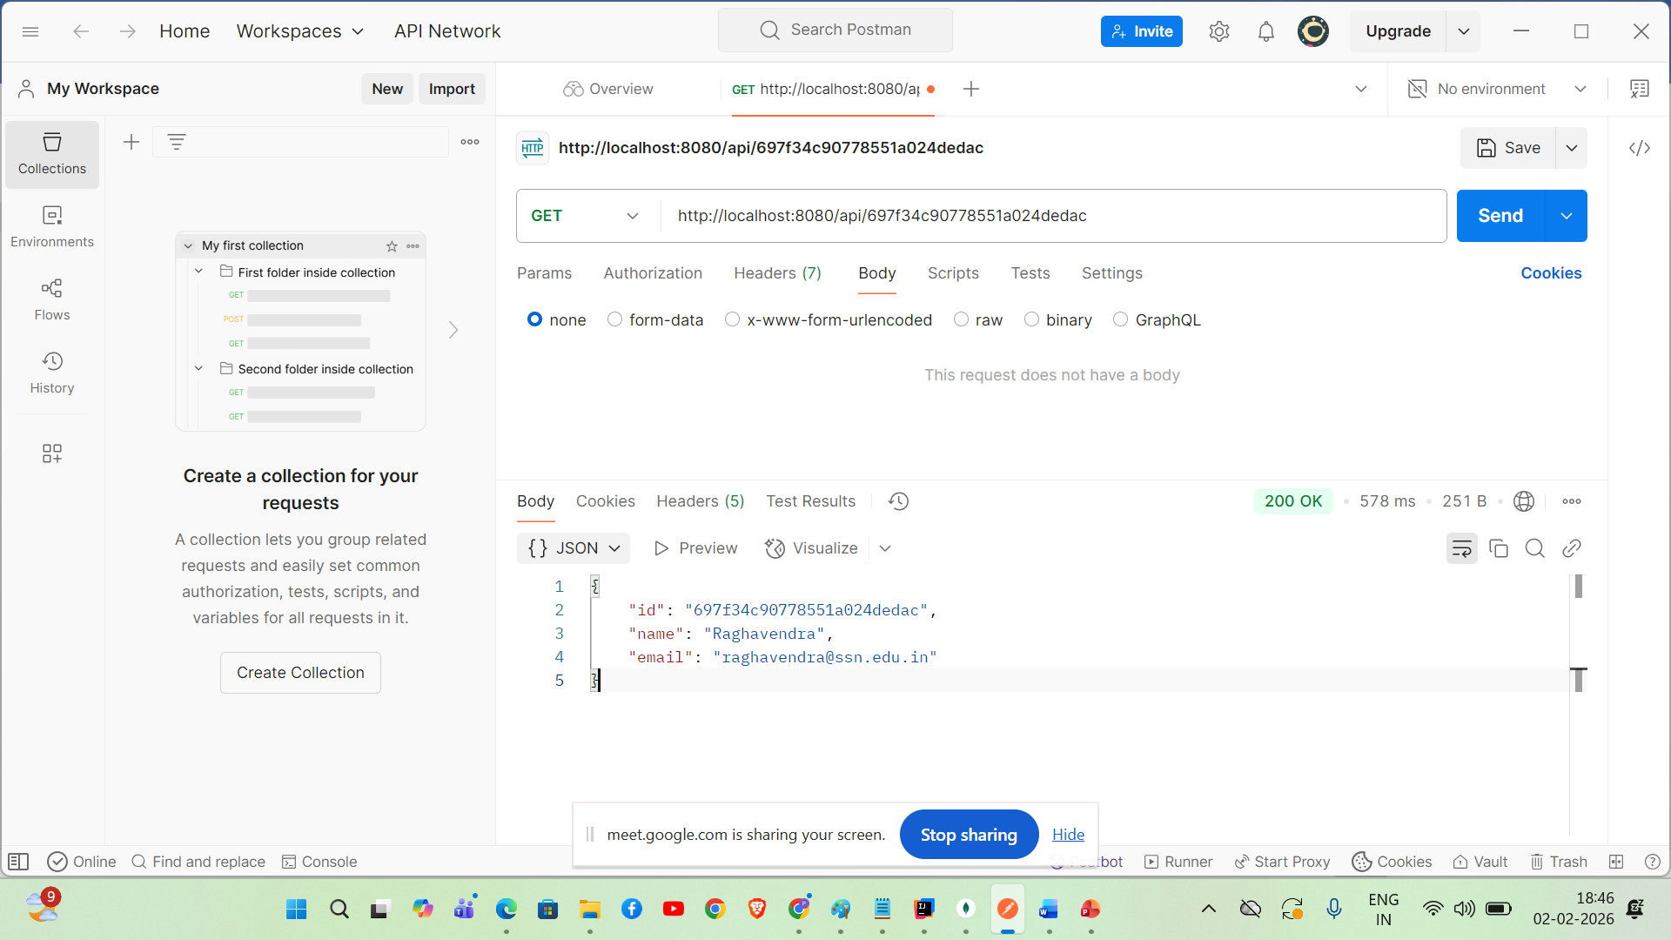

Delete document method in RestController

@DeleteMapping("/{id}")
public String deleteUser(@PathVariable String id) {
userRepository.deleteById(id);
return "User deleted successfully";
}

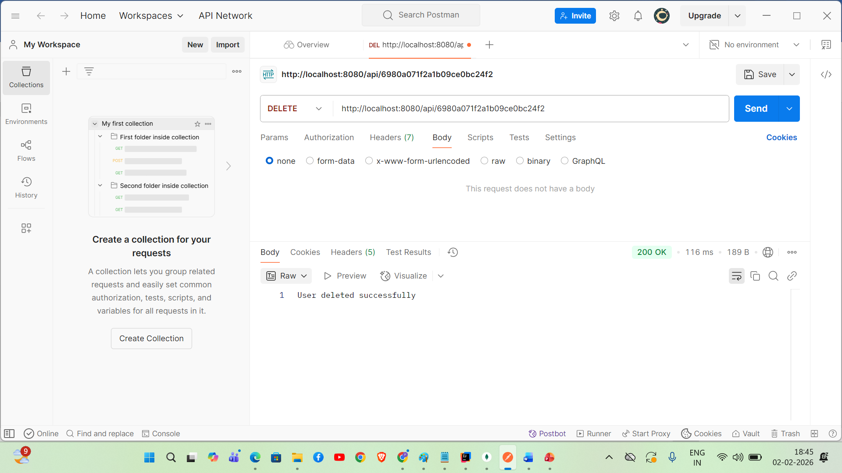

Update Document method in UserController

@PutMapping("/{id}")
public User updateUser(@PathVariable String id,
@RequestBody User updatedUser) {
return userRepository.findById(id).map(user -> {
user.setName(updatedUser.getName());
user.setEmail(updatedUser.getEmail());
return userRepository.save(user);
}).orElse(null);
}

